EDA Insights
Summary Statistics

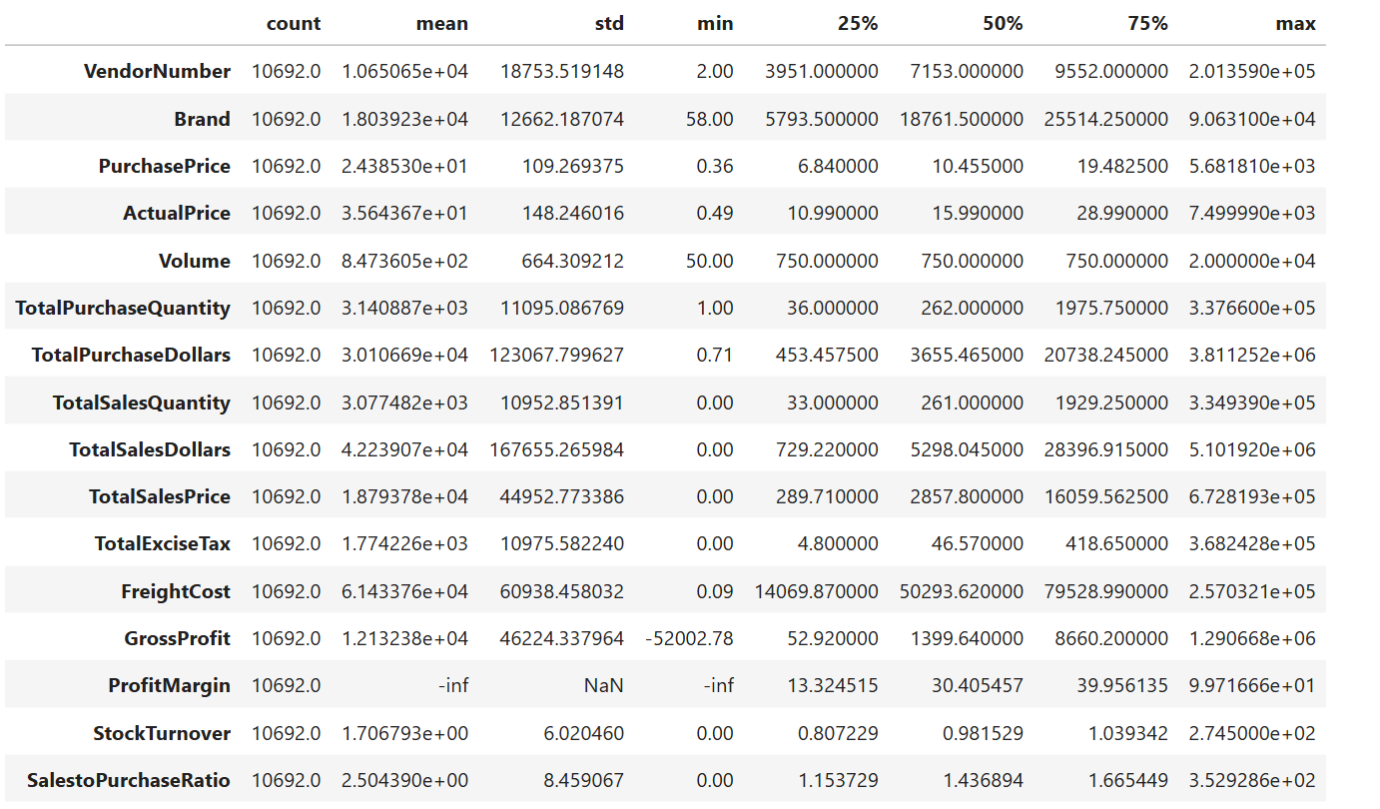
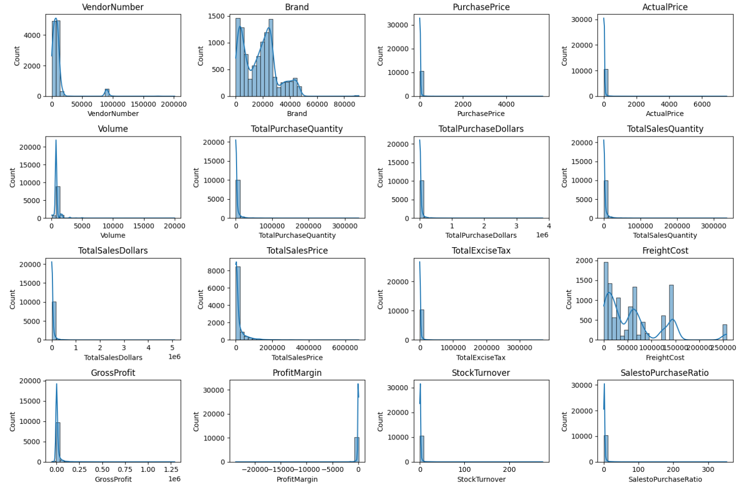
Negative & Zero Values:
-> Gross Profit: Minimum is -52002.78, indicating losses. Some products or transactions may be selling at loss due to high costs or selling at discounts lower than purchase price.
-> Profit Margin: Has a minimum of -∞, which suggests cases where revenue is zero or lower than costs.
-> Total Sales Quantity & Sales Dollars: Minimum values are 0, meaning some products were purchased but never sold. These could be slow moving or obsolete stock.
Outliers Indicated by High Strandard Deviations:
Total Sales Quantity & Sales Dollars : Some products show zero sales, indicating they where purchased but never sold. These may be slow moving items leading to inventory inefficiencies.
Outlier Detected By High Standard Deviations :
->Purchased & Actual Prices: The max values(5,681.81 & 7,499.99) are significantly higher than the mean (24.39 & 35.64), indicating potential premium products.
->Freight Cost: Huge variation, from 0.09 to 257,032.07, suggets logistics inefficiencies or bulk shipments.
->Stock Turnover: Ranges from 0 to 274.5, implying some products sell extremely fast while others remain in stock indefinitely. Value more than 1 indicates that sold quantity for that is higher than purchased quantity due to sales being fulfilled from older stock.
Data Filtering :
To enhance the reliability of the insights, we removed inconsistent data records where:

- Gross Profit <= 0 (to exclude transactions leading to losses)
- Profit Margin <= 0 (to ensure analysis focuses on profitable transactions)
- Total Sales Quantity = 0(to eliminate inventory that was never sold)

Correlation Insights :
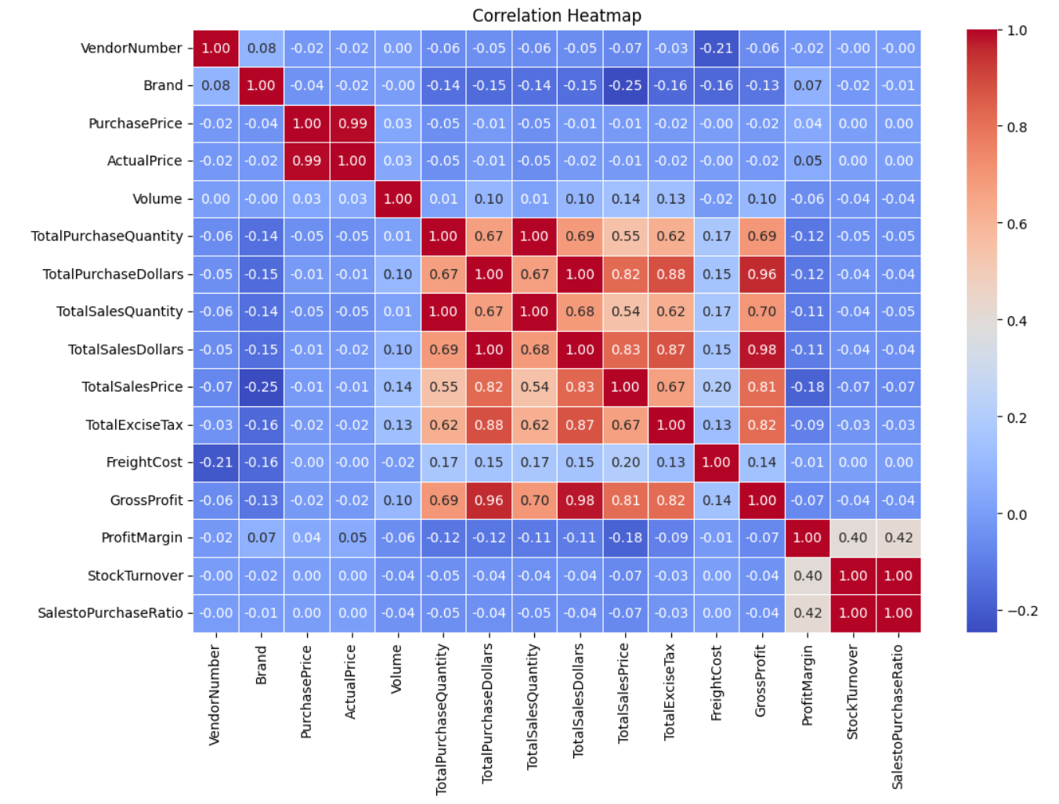
- PurchasePrice has weak correlations with TotalSalesDollars(-0.012) and GrossProfit(-0.016), suggesting that price variations do not significantly impact sales revenue or profit.
- Strong correlation between total purchase quantity and total sales quantity(0.999), confirming effecient inventory turnover.
- Negative correlation between profit margin & total sales price(-0.179) suggests that as sales price increases, margins decreases, possibly due to competitive pricing pressures.
- StockTurnover has weak negative correlations with both GrossProfit(-0.038) and ProfitMargin(-0.055), indicating that faster turnover does not necessarily result in higher profitability.

Research Questions & Key Findings :
1.Brands for Promotional or Pricing Adjustments
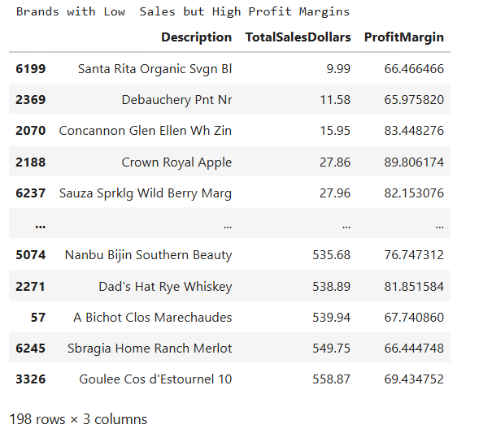

198 brands exhibit lower sales but higher profit margins, which could not benefit from targeted marketing, promotions, or price optimizations to increase volume without compromising profitability.

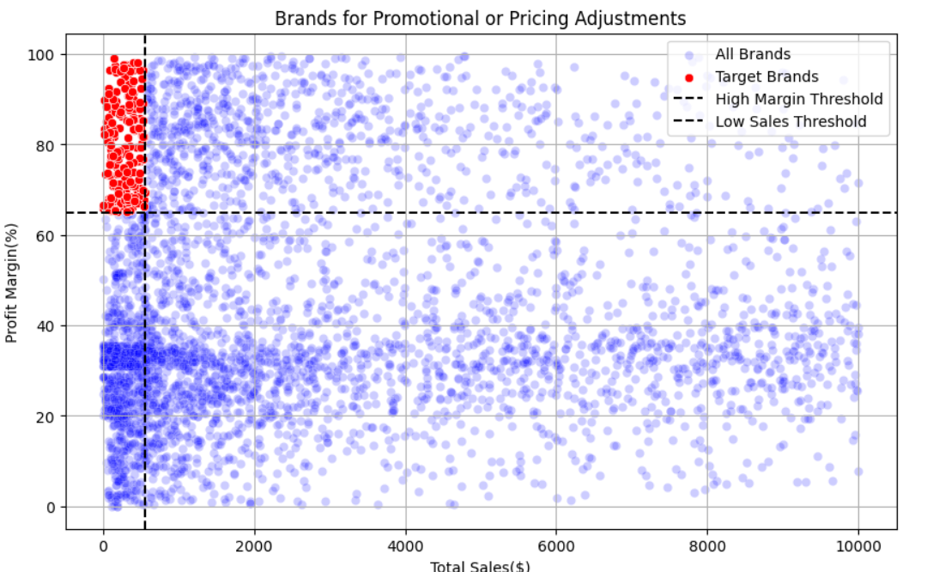

2.Top Vendors by Sales & Purchase Contribution
The top 10 vendors contribute 65.69% of total purchases, while the remaining vendors contribute only 34.31%. This over-reliance on a few vendors may introduce risk such as supply chain disruptions, indicating a need for diversification.
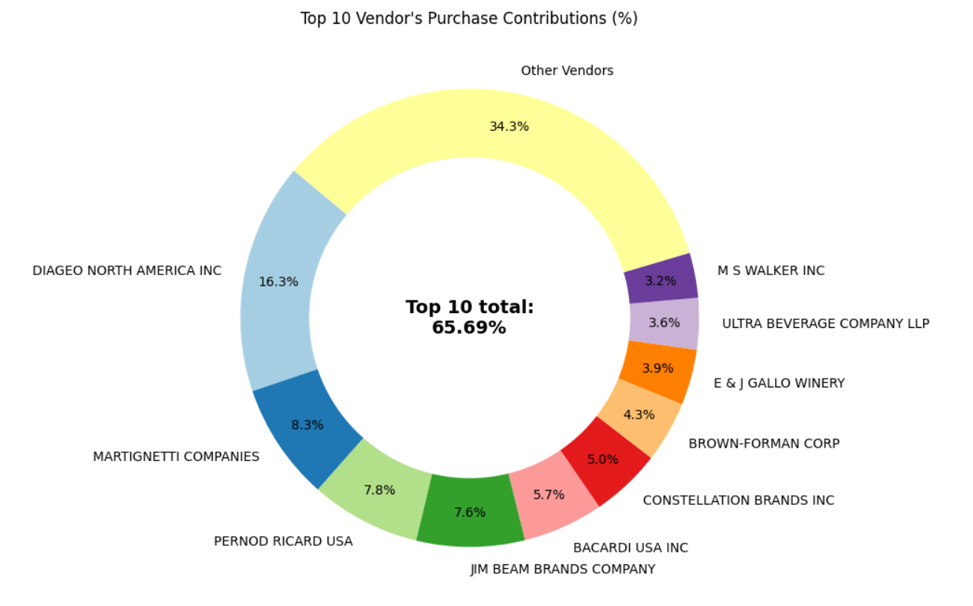

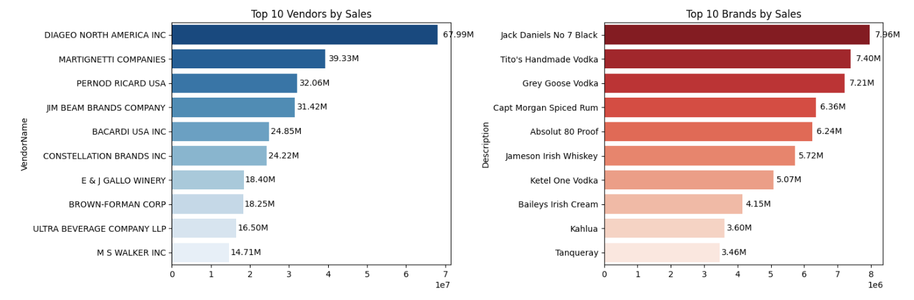
3.Impact of Bulk Purchasing on Cost Savings
Vendors buying in large quantitites receive a 72% lower unit cost ($10.78 per unit vs higher costs in smaller orders).
Bulk pricing strategies encourage large orders, increasing total sales while maintaining profitability.
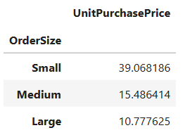
4.Identifying Vendors with Low Inventory Turnover
Total unsold inventory capital: $2.1M
Slow moving inventory increases storage costs, reduce cash flow efficiency, and affect overall profitability.
Identifying vendors with low inventory turnover enables better stock management, minimizing financial strain.
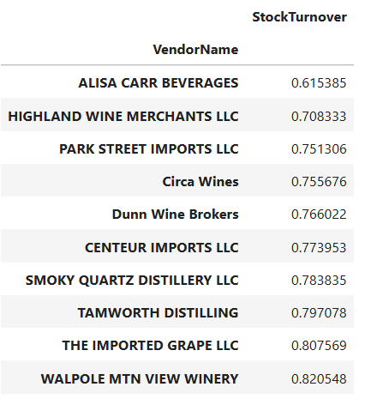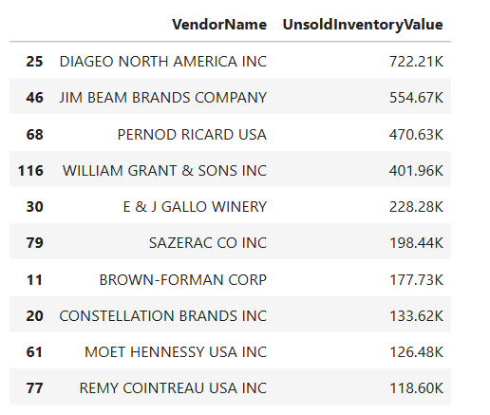
5.Profit Margin Comparison: High vs. Low Performing Vendors

Top Vendors 95% CI : (30.74, 31.61), Mean:31.18
Low Vendors 95% CI : (40.50, 42.64), Mean:41.57
- The confidence interval for low performing vendors(40.50% to 42.64%) is significantly higher than that of top performing vendors(30.74% to 31.18%).
- This suggests that vendors with lower sales tend to maintain higher profit margins, potentially due to premium pricing or lower operational costs.
- For High-Performing Vendors: If they aim to improve profitabilty, they could explore selective price adjustments, cost optimizations, or bundling stratgies.
- For Low-Performing Vendors: Despite higher margins, their low sales volume might indicate a need for better marketing, competitive pricing, or improved distribution strategies.
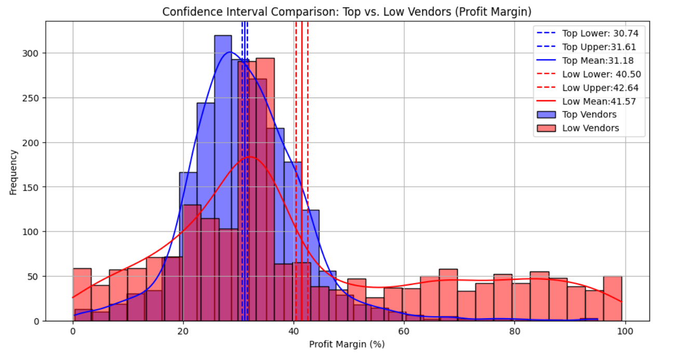

6.Statistical Validation of Profit Margin Differences
Hypothesis:
H0 (Null Hypothesis): There is no significant difference in the mean profit margins of top performing and low performing vendors.
H1 (Alternate Hypothesis): The mean profit margins of top performing and low performing vendors are significantly different.
Result: The null hypothesis is rejected, confirming that the two group operate under distinctly different profitability models.
Implications : High margin vendors may benefit from better pricing strategies, while top-selling vendors could on cost efficiency.

Final Recommendations:
- Re-evaluate pricing for low sales, high margin brands to boost sales volume without sacrificing profitability.
- Diversify vendor partnerships to reduce dependency on a few suppliers and mitigate supply chain risks.
- Leverage bulk purchasing advantages to maintain competitive pricing while optimizing inventory management.
- Optimize slow-moving inventory by adjusting purchase quantities, launching clearance sales, or revising storage strategies.
- Enhance marketing and distribution strategies for low-performing vendors to drive higher sales volumes without compromising profit margins.
- By implementing these recommendations, the company can achieve sustainable profitability, mitigate risks, and enhance overall operational efficiency.

